[ Insert official UPAEP logo ]
UPAEP · Decanato de Ingenierías
EVIDENCE — US11-T1
Design the alert engine and alert data model
SmartGreenAI: Cilantro Crop

1. Task information
Task ID | US11-T1
User Story | US-11 — Receive threshold alerts
Sprint | Sprint 3 (2026-10-12 – 2026-10-30)
Week | Week 1
Responsible | Jorge Velez Delgado
Peer reviewer | Alexis Enrique Valle Parra
Planned / actual hours | 2 h / 2 h
Completed on | October 16, 2026
Status | Done

2. Task description
Define the alerts table (id, sensor_id, threshold_id, type LOW/HIGH, value, severity, status OPEN/ACKNOWLEDGED/RESOLVED, created_at, resolved_at) and the rules: below min creates a LOW alert, above max creates a HIGH alert, only one open alert per sensor and type, automatic resolution when the value returns to range.

3. Completion conditions
✓ Condition 1: Alert fields defined and added to the shared ER diagram.
How it was verified: The alert fields (id, sensor_id, threshold_id, type LOW/HIGH, value, severity, status OPEN/ACKNOWLEDGED/RESOLVED, created_at, resolved_at, plus who acknowledged it) are in the shared ER diagram and in the alerts table.
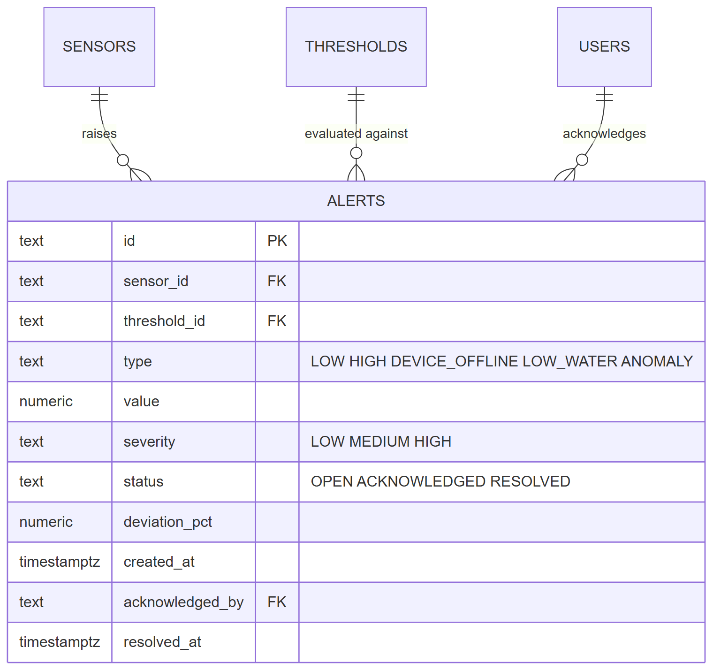
Figure US11-T1-1. Alert entity added to the shared ER diagram. (US11-T1_Design_Alert_Engine_Alert_Data_1.png)
Alert fields in the database (15 rows; US11-T1_Design_Alert_Engine_Alert_Data_3.csv)
column_name | data_type | is_nullable
id | text | NO
sensor_id | text | YES
device_id | text | YES
area_id | text | YES
threshold_id | text | YES
type | text | NO
value | numeric | YES
severity | text | NO
status | text | NO
message | text | NO
deviation_pct | numeric | YES
created_at | timestamp with time zone | NO
acknowledged_by | text | YES
acknowledged_at | timestamp with time zone | YES
resolved_at | timestamp with time zone | YES
SQL: SELECT column_name, data_type, is_nullable FROM information_schema.columns WHERE table_name = 'alerts' ORDER BY ordinal_position
✓ Condition 2: LOW/HIGH, de-duplication and auto-resolve rules documented.
How it was verified: Rules: below the minimum → LOW alert; above the maximum → HIGH alert; only one open (or acknowledged) alert per sensor and type, guaranteed by a unique partial index; the alert resolves itself when the value returns to the range.
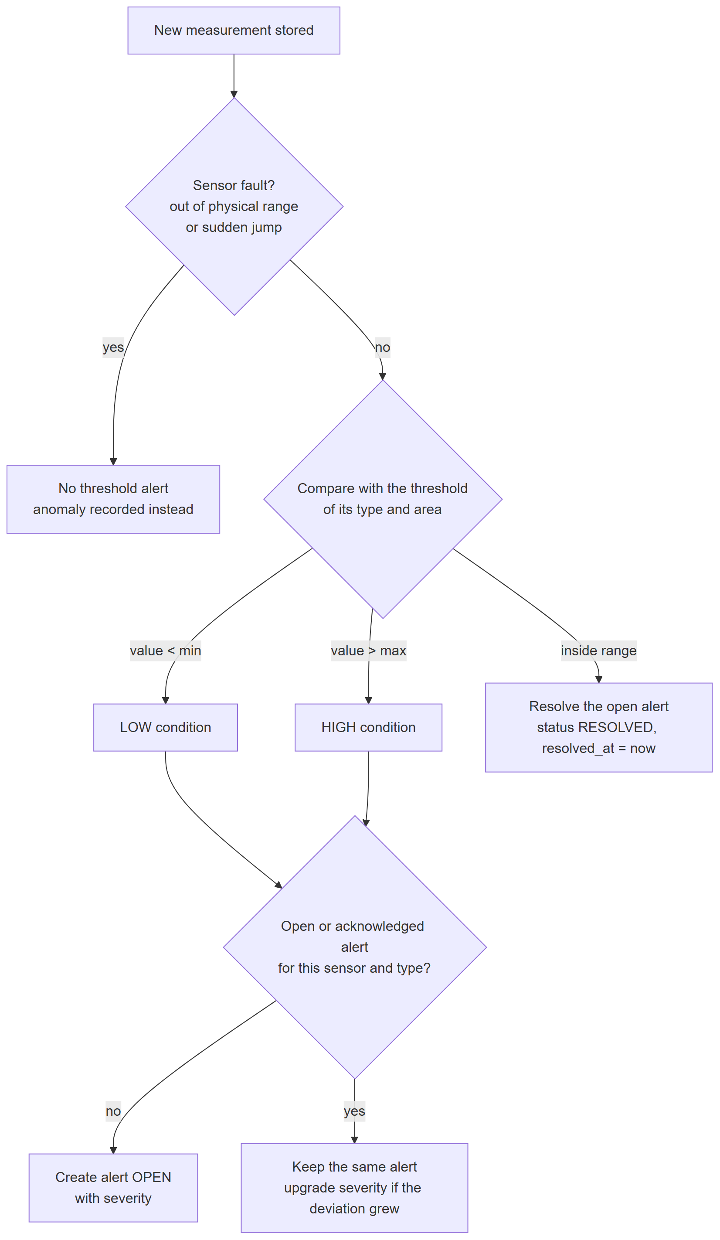
Figure US11-T1-2. Alert rules: LOW/HIGH, de-duplication and automatic resolution. (US11-T1_Design_Alert_Engine_Alert_Data_2.png)
De-duplication enforced by the database (one open alert per sensor and type) (2 rows; US11-T1_Design_Alert_Engine_Alert_Data_5.csv)
indexname | indexdef
uq_alerts_open_sensor_type | CREATE UNIQUE INDEX uq_alerts_open_sensor_type ON public.…
uq_alerts_open_device_type | CREATE UNIQUE INDEX uq_alerts_open_device_type ON public.…
SQL: SELECT indexname, indexdef FROM pg_indexes WHERE tablename = 'alerts' AND indexname LIKE 'uq_%'
server/src/modules/alerts/service.js — lines 73–102
async function evaluateMeasurement(sensor, measurement) {
const threshold = await resolveThreshold(sensor);
if (!threshold) return { created: false, resolved: false, alert: null };
const value = Number(measurement.value);
const min = Number(threshold.min_value);
const max = Number(threshold.max_value);
const label = VARIABLE_LABEL[sensor.type] || sensor.type;
// Darkness at night is not a problem: the light minimum applies only during
// the daylight hours of the greenhouse (local time of the reading).
const nightLight = sensor.type === 'light' && value < min && !(await daylight.isDaylight(measurement.recorded_at));
const isLow = value < min && !nightLight;
const isHigh = value > max;
// --- Back inside the range: resolve whatever was open (US11-T4) ---------
if (!isLow && !isHigh) {
const resolved = await db.query(
`UPDATE alerts
SET status = 'RESOLVED', resolved_at = NOW()
WHERE sensor_id = $1 AND type IN ('LOW', 'HIGH') AND status IN ('OPEN', 'ACKNOWLEDGED')
RETURNING id`,
[sensor.id],
);
return { created: false, resolved: resolved.rowCount > 0, alert: null };
}
const type = isLow ? 'LOW' : 'HIGH';
const deviation = deviationPercent(value, min, max);
const lowMax = await settings.getNumber('severity.low_max_pct', 10);

✓ Condition 3: Design reviewed by Carlos (US-12, US-13).
How it was verified: The design was reviewed by Carlos, owner of US-12 (severity) and US-13 (history) (approval record).
✓ Condition 4: Evidence: Alert data model and rule description reviewed by the team.
How it was verified: Alert data model and rule description reviewed by the team.

4. Attached files
- US11-T1_Design_Alert_Engine_Alert_Data_1.png
- US11-T1_Design_Alert_Engine_Alert_Data_2.png
- US11-T1_Design_Alert_Engine_Alert_Data_3.csv
- US11-T1_Design_Alert_Engine_Alert_Data_4.sql
- US11-T1_Design_Alert_Engine_Alert_Data_5.csv
- US11-T1_Design_Alert_Engine_Alert_Data_6.sql

5. Traceability
Related requirements | FR-12, FR-13, FR-22
Implementation | schema.sql → alerts (+ unique index: one open alert per sensor and type); docs/ARCHITECTURE.md ingestion diagram
Verification | —

6. Sign-off
Role | Name | Date | Signature
Responsible | Jorge Velez Delgado | October 16, 2026
Peer reviewer | Alexis Enrique Valle Parra | October 16, 2026
Product Owner acceptance | Alexis Enrique Valle Parra | October 16, 2026
Approval record: Daily Meeting 2 of Sprint 3 (Monday, October 19, 2026), Scrum board: "Tasks moved to Done last week: US11-T1, US11-T2, US12-T1, US13-T1, US13-T2, US15-T1, US15-T2, US15-T3, US15-T4, US15-T5 (early), US16-T1, US16-T2, US17-T1, US19-T1, US19-T2, US19-T3."

